Lesson 4. Building and Rebuilding Trust

This page intentionally left blank.

INTRODUCTION
Visual 4.1

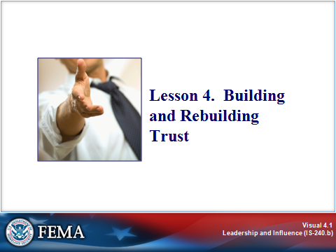
Key Points

In the last lesson, we examined the phenomenon of change, and how an effective leader facilitates change. One of the most striking casualties of change is trust. The speed and frequency of change, and its often unintended consequences, often result in erosion of loyalty and trust that can continue to undermine an organization for years.

The relationship between change and trust is full of irony. You can’t effectively facilitate change without mutual trust. But one of the hardest things to do in a changing organization is to build trust. Even more difficult is to rebuild trust after it is lost.

In this lesson, we will examine the issue of trust and explore ways in which an effective leader can build or rebuild trust among employees and other emergency management stakeholders.

INTRODUCTION
Visual 4.2

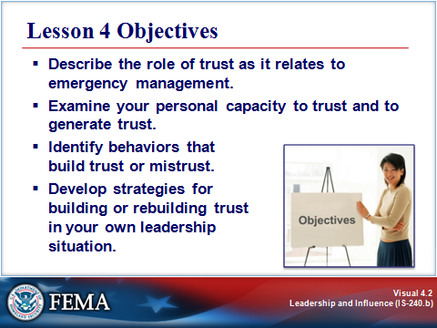
Key Points

After completing this lesson, you should be able to:

- Describe the role of trust as it relates to emergency management.
- Examine your personal capacity to trust and to generate trust.
- Identify behaviors that build trust or mistrust.
- Develop strategies for building or rebuilding trust in your own leadership situation.

TRUST
Visual 4.3

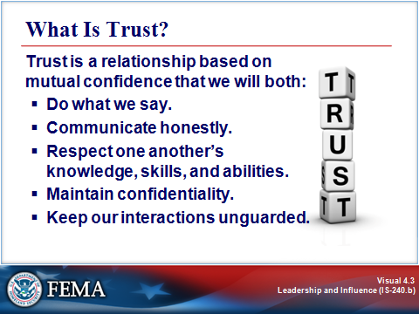
Key Points

Trust is a relationship based on mutual confidence that we will both:

- Do what we say.
- Communicate honestly.
- Respect one another’s knowledge, skills, and abilities.
- Maintain confidentiality.
- Keep our interactions unguarded.

Trust is a state of mind. Notice that all of these things are actions. It’s not our words that generate trust, but what we do. The real message is in our actions. Trust is a combination of trusting others and being trustworthy.

TRUST
Visual 4.4

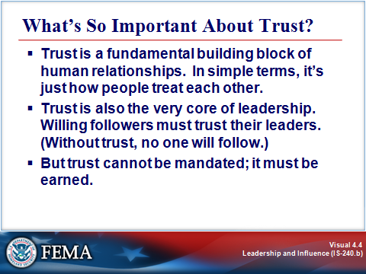
Key Points

Trust is a fundamental building block of human relationships. In simple terms, it’s just how people treat each other.

Trust is also the very core of leadership. Willing followers must trust their leaders. (Without trust, no one will follow.) But trust cannot be mandated; it must be earned.

An earlier lesson pointed out that people working out of the Leader paradigm get their credibility and power “from behavioral integrity⎯‘walking the talk and talking the walk.’ Leaders’ power comes from their consistent, principle-centered behavior and actions that demonstrate honesty, integrity, trust, dignity, and respect for all people.” When leaders demonstrate behavioral integrity, people choose to follow them.

TRUST
Visual 4.5

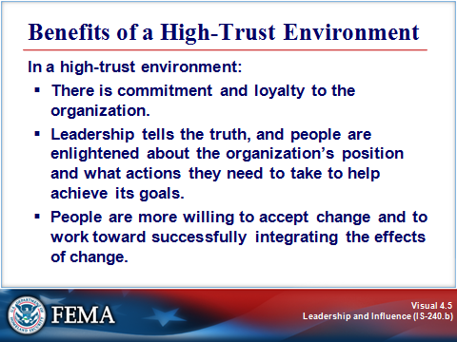
Key Points

A high-trust environment creates commitment and loyalty to the organization. When people get the idea, “We’re all in this boat together,” the organization is invariably better for it.

In a high-trust environment, leadership tells the truth, and people are enlightened about the organization’s position and what actions they need to take to help achieve its goals.

In a high-trust environment, people are more willing to accept change and work together toward successfully integrating the effects of change.

TRUST
Visual 4.6

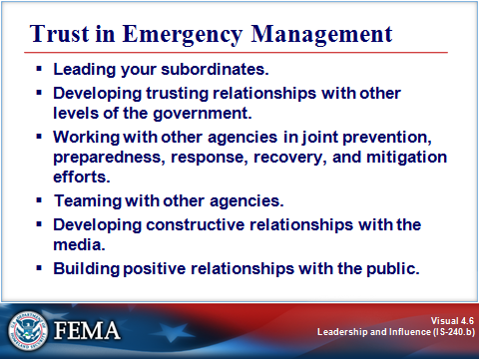
Key Points

Every manager in business, industry, and government has an important leadership role in building a high-trust environment with his or her employees.

As a leader within emergency management, you have a more complex role of building trust at multiple levels. Trust is a necessary element of:

- Leading your subordinates to work energetically toward meeting the organization’s goals.
- Developing trusting relationships with other levels of the government hierarchy to ensure a coordinated response to the needs of the community in times of crisis.
- Working with other agencies in joint prevention, preparedness, response, recovery, and mitigation efforts, including evaluation of hazards, planning, interagency exercises, and voluntary agreements.
- Teaming with other agencies in disaster response and recovery efforts.
- Developing constructive relationships with the media to ensure effective cooperation in public education, warning, and response communications.
- Building positive relationships with the public that will foster willing response and cooperation during times of emergency.

The effective response to the first World Trade Center bombing was attributed to the years of interagency cooperation, careful evaluation of hazards and planning, and meaningful interagency exercises. This same foundation of trust undoubtedly played an equally important part in the cooperative response efforts that followed the 2001 attack that destroyed the World Trade Center. In short:

Your relationships with local, State, and Federal officials, with other organizations, with the media, and with the public will affect your ability to manage a disaster successfully. Those relationships are built on a foundation of trust.

TRUST
Visual 4.7

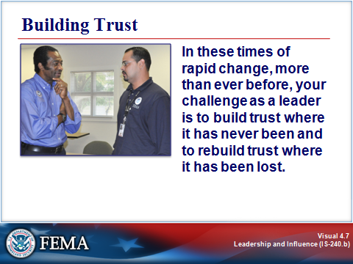
Key Points

When things are continually changing, it can become difficult to build a case for trust. It’s almost as if you are saying, “Trust me. I’ve never done this either!”

In these times of rapid change, more than ever before, your challenge as a leader is to build trust where it has never been and to rebuild trust where it has been lost.

Many of the strategies discussed in Lesson 3 will help you to minimize the erosion of trust. How else can you, as a leader, build trust among your constituents⎯whether they are employees, those above you in rank, your peers in other organizations, the media, or the public?

ACTIVITY: TRUST BEHAVIORS
Visual 4.8

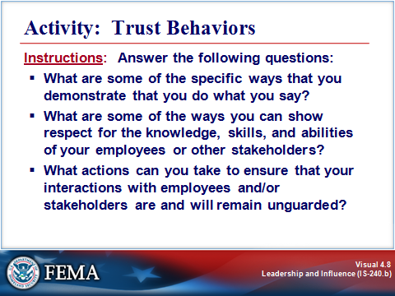
Key Points

Purpose: The purpose of this activity is to examine your trust behaviors.

Time: 5 minutes

Instructions: Answer the following questions:

- What are some of the specific ways that you demonstrate that you do what you say?
- What are some of the ways you can show respect for the knowledge, skills, and abilities of your employees or other stakeholders?
- What actions can you take to ensure that your interactions with employees and/or stakeholders are and will remain unguarded?

TRUSTWORTHINESS
Visual 4.9

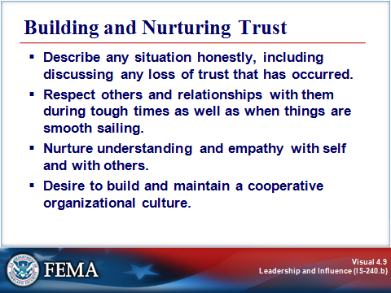
Key Points

Building and nurturing trust in the workplace requires leaders who:

- Honestly describe any situation they are in, including discussing any loss of trust that has occurred.
- Respect others and relationships with them during tough times as well as when things are smooth sailing.
- Nurture understanding and empathy with themselves and with others.
- Desire to build and maintain a cooperative organizational culture.

TRUSTWORTHINESS
Visual 4.10

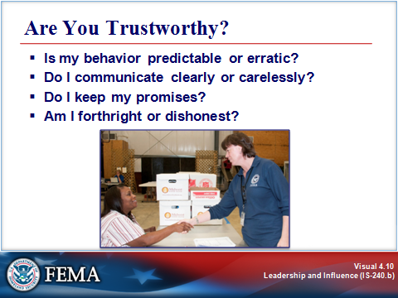
Key Points

Demonstrating trustworthiness is critical if you want to successfully manage change, and you should periodically gauge how worthy of trust your own behavior is. You can use the following questions as a starting point.

- Is my behavior predictable or erratic? Do people know what to expect from me? Do my actions match the values I espouse? Your actions should follow your words and should stay constant regardless of the times or people you are working with.

- Do I communicate clearly or carelessly? Some people speak without thinking of the impression their words leave behind and how they impact people’s lives. When you speak without considering the impact of your words, people begin to think you are flippant and not worthy of trust.

- Do I keep my promises? If you don’t keep your promises, then neither will those you work with. If people cannot tell what you value and will follow through on, confusion and mistrust will result.

- Am I forthright or dishonest? No one trusts someone who lies. Honesty doesn’t mean that you disclose everything when it isn’t appropriate, but you need to be honest about what you can and cannot discuss.

TRUSTWORTHINESS
Visual 4.11

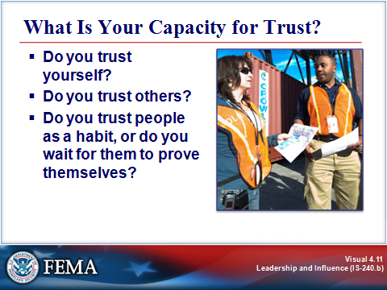
Key Points

Your ability to trust others reflects to some extent your ability to trust yourself.

The following questions will help you begin to think about your capacity for trusting others.

- Do you trust yourself?

- In what types of situations can you answer “yes” and in which is the answer “no”?
- In what ways do you consider yourself reliable?
- In what ways do you consider yourself unreliable?

- Do you trust others?

- When can you say “yes” to this? When do you say “no”?
- What do you look for when considering whether another person is trustworthy?

- Do you trust people as a habit, or do you wait for them to prove themselves?

- How does this approach to trusting affect how you work with others?

TRUSTWORTHINESS
Visual 4.12

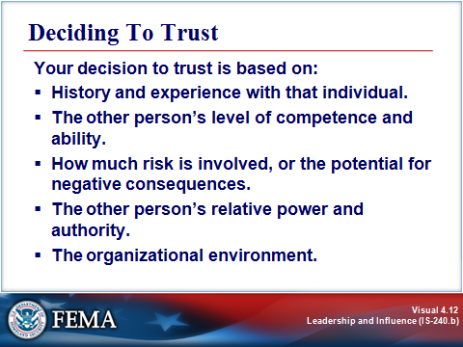
Key Points

Your capacity for building trusting relationships, in general, is a function of your propensity to use trust-enhancing behaviors and the degree to which you expect others to use them.

But what about specific relationships? Your decision to trust a specific person, and the degree of trust that you place in that person, are influenced by many factors, including:

- History and experience with that individual.
- The person’s level of competence and ability.
- How much risk is involved, or the potential for negative consequences.
- The person’s relative power and authority.
- The organizational environment.

So, you can work diligently on your general propensity to trust, but some people will still let you down. Does that mean that you shouldn’t trust?

No, because although trust can be person-specific and situation-specific, you still have a general propensity to (or not to) trust. And that propensity will in turn influence the decisions that you make. Most people can stand to expand their capacity for trust.

TRUSTWORTHINESS
Visual 4.13

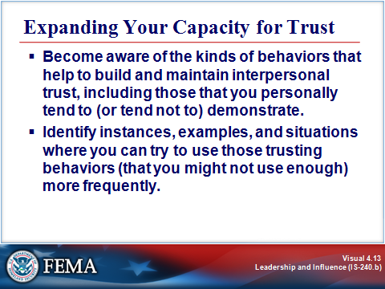
Key Points

First, you can simply be aware of the kinds of behaviors that help to build and maintain interpersonal trust, including those that you personally tend to (or tend not to) demonstrate.

Then, you can identify instances, examples, and situations where you can try to use those trusting behaviors (that you might not use enough) more frequently.

The self-assessment on the next page, Reflecting on Your Trust Behaviors, can help you identify how to strengthen trust in your workplace.

Self-Reflection: Reflecting on Your Trust Behaviors

Demonstrating trustworthiness is critical if you want to successfully manage change, and you should periodically gauge how worthy of trust your own behavior is. You can use the following questions as a starting point.

- Is my behavior predictable or erratic?

Do people know what to expect from you? Do your actions match the values you espouse? Your actions should match your words and stay constant regardless of the situation or people around you.

- Do I communicate clearly or carelessly?

Some people speak without thinking of the impression their words leave behind and how they impact people’s lives. When you speak without considering the impact of your words, people begin to think you are flippant and not worthy of trust.

- Do I keep my promises?

If you don’t keep your promises, then neither will those who work with you. If people cannot tell what you value and will follow through on, confusion and mistrust will result.

- Am I forthright or dishonest?

No one trusts someone who lies. Honesty doesn’t mean that you disclose everything when it isn’t appropriate, but you need to be honest about what you can and cannot discuss.

Instructions: List at least one action you can take to improve in each of the following areas.

- To improve the predictability of my behavior, I can:
- To improve the clarity of my communication, I can:
- To improve the seriousness with which I treat my promises, I can:
- To improve my forthrightness, I can:

REDUCING TRUST
Visual 4.14

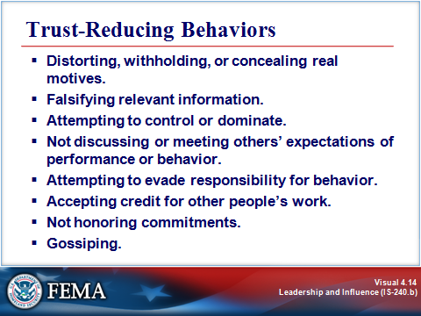
Key Points

We have discussed a number of ways to build trust and fulfill the expectations of a trusting relationship: doing what we say; communicating honestly; respecting one another’s knowledge, skills, and abilities; maintaining confidentiality; and keeping our interactions unguarded.

Just as consistently fulfilling expectations strengthens trust, failure to act in these ways invariably undermines and erodes trust. For example, the following types of behavior will invariably reduce trust:

- Distorting, withholding, or concealing real motives.
- Falsifying relevant information.
- Attempting to control or dominate.
- Not discussing or meeting others’ expectations of performance or behavior.
- Attempting to evade responsibility for behavior.
- Accepting credit for other people’s work.
- Not honoring commitments.
- Gossiping.

Any of these behaviors can be intentional or unintentional.

Remember, building trust is a slow process, and trust can be destroyed by a single event. Trust is destroyed by a win/lose mentality, and trust is strengthened by a win/win mentality.

ACTIVITY: TRUST VS. MISTRUST
Visual 4.15

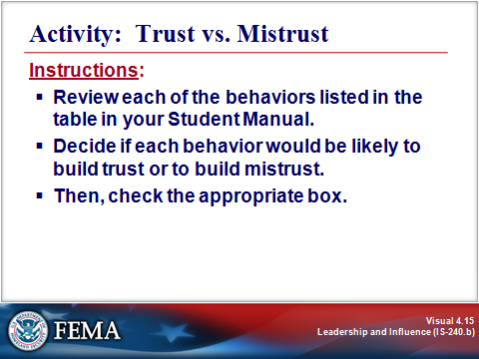
Key Points

Purpose: The purpose of this activity is to identify behaviors that build trust and those that build mistrust.

Time: 5 minutes

Instructions:

- Review each of the behaviors in the table beginning on the next page.

- Decide if it would be likely to build trust or to build mistrust.

- Then, check the appropriate box.

ACTIVITY: TRUST VS. MISTRUST
Visual 4.15 (Continued)

Activity: Trust vs. Mistrust

Behavior | Builds Trust | Builds Mistrust
- When in doubt about taking on a commitment, air your concerns with the relevant parties. |  | 
- Be unclear or not exactly explicit about what you need or expect. Assume that anyone would know to do or not do that. |  | 
- Solve problems through direct communication at the lowest equivalent levels: yourself and peers; yourself and your direct manager; yourself, your manager, and his/her manager. |  | 
- When engaged in an ongoing commitment, communicate anticipated slippage as soon as you suspect it. |  | 
- Make a pretended or “soft” commitment (e.g., “I’ll respond later.”). |  | 
- Schedule regular meetings for input and feedback for those reporting to you. |  | 
- Acknowledge the intent and risk of innovation first; then address the issue with your honest opinion. |  | 
- Talk with others about problems you are having with a peer, without doing everything reasonably possible to solve the problem through direct communication with that peer. |  | 
- Spend informal time mingling, asking nonassumptive questions, making only promises you can keep, and working back through existing lines of authority. |  | 
- Take credit for yourself, or allow others to give you credit for an accomplishment that was not all yours. |  | 
- Communicate abruptly when others venture new opinions or efforts. |  | 
- Have performance evaluation time be the only, or primary, time for coaching input. |  | 
- Engage in tactful, direct communication, airing your problem and seeking win-win resolution. |  | 
- Withhold deserved recognition at times when you, yourself, are feeling underrecognized. |  | 

ACTIVITY: TRUST VS. MISTRUST
Visual 4.15 (Continued)

Activity: Trust vs. Mistrust (Continued)

Behavior | Builds Trust | Builds Mistrust
- Manage or supervise from behind your desk only. |  | 
- Share credit generously. When in doubt, share. |  | 
- Be explicit and direct. If compromise is productive, do it in communication, not in your mind alone. |  | 
- Be timely. |  | 
- Be willing to be wrong. |  | 
- Withhold potentially useful information, opinions, or action until the drama heightens, thus minimizing your risk of being wrong and maximizing credit to you if you’re right. |  | 
- Hold in your mind another department’s productivity or behavior as a reason for less cooperation. |  | 
- Extend yourself beyond your own short-term feeling and validate success or new effort. |  | 
- Develop systems for staff to evaluate supervisors and managers. |  | 

WHEN TRUST BREAKS DOWN
Visual 4.16

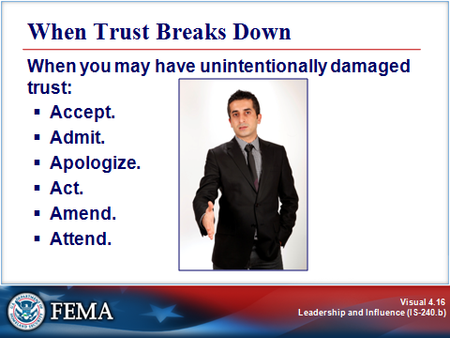
Key Points

You’ll probably survive one unintentional breach of trust, especially if you take action to address the situation. But as unintentional breaches accumulate, other people will eventually begin to distrust you. With their distrust will come the belief that your intentions are not sincere and that you have ulterior motives.

After you’ve breached trust, it is important to consider how to restore it. Here are six steps that you can take to recover from a mistake that may have unintentionally damaged trust.

- Accept. Accept personal responsibility for your actions and those of your organization.
- Admit. Publicly acknowledge that you have made a mistake. Many times, leaders either deny or attempt to cover up any wrongdoing for fear that admitting a mistake might damage their credibility. Evidence shows that attempting to hide mistakes will be much more damaging and will actually erode trust.
- Apologize. Offer an apology. Apologizing lets others know that you are concerned about the impact or problem that your actions may have created.
- Act. Take action to deal with the immediate consequences of a mistake. Taking action lets employees know that you are willing to do something. This is a good time to get others involved by asking for suggestions and trusting their judgment.
- Amend. Make amends. A leader’s error can cause undue hardship to others. The amends should fit the problem.
- Attend. Leaders need to make sure that they are attuned to the influence their actions are having on rebuilding lost trust. Pay close attention to the reactions of those who are affected, ask for feedback, and be nondefensive in listening to constructive criticism. This feedback process should also help you avoid unintentional breaches of trust in the future.

The self-reflection on the next page can help you identify strategies for building and rebuilding trust in your workplace.
Self-Reflection: Building Trust in Your Situation

Instructions: Think back to a situation at work in which you did something in your leadership role that impacted your trust relationship with others—perhaps with your coworkers, with stakeholders, with your team, and/or with senior management. The impact on trust could have been a positive or a negative one. Now answer the following questions. (Remember: No one will see what you write down here!)

- What actions were taken (or could be taken) to strengthen trust (or at least not compromise it)?
- In what ways and under what circumstances (either intentional or unintentional) might you have caused or reinforced mistrust during this situation?
- Based on this analysis, what actions can you take to build and rebuild trust in the future?
- Based on this analysis, what actions can others (i.e., coworkers, team members, and/or senior management) take to build and rebuild trust in the future?

CASE STUDY: THE GRAPEVINE, PART I
Visual 4.17

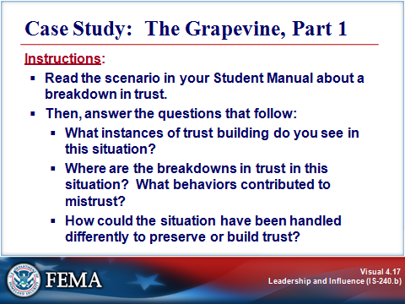
Key Points

Purpose: The purpose of this activity is to examine trust behaviors.

Time: 10 minutes

Instructions: Read the following scenario about a breakdown in trust. Then answer the questions that follow.

Scenario:

John Wallace leads the Logistics department at an emergency response organization. When he assumed the position a year ago, he encountered numerous personnel problems. Since then, he has worked to change the culture. He established clear expectations and timelines, and he has given people clear and ongoing feedback on their performance. John prides himself on being open, honest, and fair and has been forthright with his own supervisor, Juanita Kelly, division director for Operations.

Two employees, Dewayne and Ella, tell John what they heard at lunch. Two team leaders from the other department in their division said they had heard that senior management had decided to go with a new software package that Logistics had been testing. The package will be used in deployment and tracking of emergency resources (including personnel, equipment, supplies, volunteers, shelter space, and donations) as well as purchasing and replacement. The decision was made despite the department’s recommendation to the contrary because of bugs in the program. They also heard that there would be staffing cuts to pay for the software and take advantage of the efficiencies it’s supposed to create.
CASE STUDY: THE GRAPEVINE, PART I
Visual 4.17 (Continued)

Scenario: (Continued)

John had heard several months ago that the package would undergo further testing, and he hadn’t heard much about it since. So he tells Dewayne and Ella that it’s probably all speculation and that there’s no truth to the rumors. If it were true, he would have heard about it long before they did because of how well connected he is with the division’s decisionmakers.

The next day, the software implementation and its impact on division personnel comes up in a staff meeting, and John again disputes the “rumors,” wondering aloud why it has caused such a stir now. He promises to check it out with his supervisor. When he tries to do so, he finds that she is out the rest of the week. So, he tells the staff that he’ll let them know when he finds out more.

Juanita, John’s supervisor, calls during the weekend and tells him that the Executive Committee decided that they needed to go with the new package because the “price was too good to be true.” The vendor offered a huge discount in exchange for a quick decision. When the organization hesitated during negotiations, the vendor offered to upgrade the software as needed over the next 5 years.

Juanita asks John to “keep a lid” on the announcement until senior management can put together an organization-wide announcement. Part of the announcement will be a 15-percent reduction in division staffing over the next year. John explains that he’s already been hearing about it through the grapevine. Juanita apologizes for not letting him know earlier, and expresses dismay with the organization’s inability to “manage” these communications, and relief that no one in her division caused it.

On Monday, John and Juanita talk further. She says that, while the new package has some problems, the vendor is strong and very committed to working them out. She sees the change as an opportunity to:

- Improve public safety through quicker deployment of needed resources.
- Save money by reducing the number of staff required to run and support the program.
- Improve overall efficiency and communications among the various departments.
- Lighten the workload of employees who previously have had to do a lot of manual tracking and recording.

She sees a “natural fit” for John’s department to “join hands” with the other department. While this makes sense on paper, historically there has been little cooperation between the two departments, mainly because the other department has a reputation for poor service and low morale.

On Tuesday, Dewayne drops by and asks John if he has any answers yet. John tells him what he knows (i.e., he spills the beans). Through the rest of the day, he visits with the staff and passes on, in general terms, the same information.

CASE STUDY: THE GRAPEVINE, PART I
Visual 4.17 (Continued)

Scenario Questions:

- What instances of trust building do you see in this situation?
- Where are the breakdowns in trust in this situation? What behaviors contributed to mistrust?
- How could the situation have been handled differently to preserve or build trust?
SUMMARY AND TRANSITION
Visual 4.18

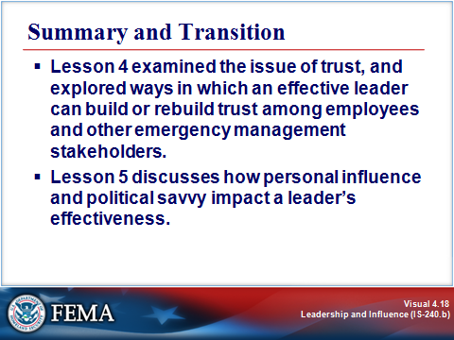
Key Points

Lesson 4 examined the issue of trust, and explored ways in which an effective leader can build or rebuild trust among employees and other emergency management stakeholders. Lesson 5 discusses how personal influence and political savvy impact a leader’s effectiveness.

For More Information:

Books:

- Building Trust at the Speed of Change: The Power of the Relationship-Based Corporation. Marshall, Edward M. AMACOM, 1999.

- Trust and Betrayal in the Workplace: Building Effective Relationships in Your Organization, 2nd edition. Reina, Dennis, and Reina, Michelle. Berrett-Koehler Publishers, 2006.

- Building Trust: A Manager's Guide for Business Success. Shurtleff, Mary Galbreath. Crisp Learning Publications, 1998.

- Driving Fear out of the Workplace: Creating the High-Trust, High-Performance Organization. Ryan, Kathleen D., and Oestreich, Daniel K. Jossey-Bass, 1998.

